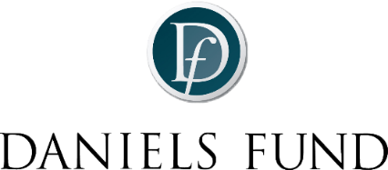 |  | 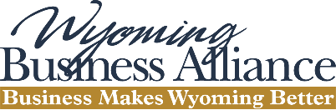
Bill Daniels Ethical Leadership Award Nomination Form

Wyoming citizens who embody the “Best of the Best” in the business community, specifically demonstrating the ethical leadership principles exhibited by Bill Daniels, a cable-television pioneer who started his professional career in Casper, Wyoming.

Nominations for the 2022 Bill Daniels Ethical Leadership Award are now being accepted. Those considered for this prestigious award will be evaluated based on the Daniels Fund Ethics Initiative Principles:

Daniels Fund Ethics Initiative Principles and Inductee Selection Criteria

Integrity – Act with honesty in all situations
Trust – Build trust in all stakeholder relationships
Accountability – Accept responsibility for all decisions
Transparency – Maintain open and truthful communications
Fairness – Engage in fair competition and create equitable and just relationships
Respect – Honor the rights, freedoms, views and property of others
Rule of Law – Comply with the spirit and intent of laws and regulations
Viability – Create long-term value for all relevant stakeholders

To nominate a deserving individual, please complete the following form in its entirety.
Nominations are due by July 15, 2022 and should be submitted to cindy@wyoba.com

Nominator Information
Your Name:
Your organization:
Your email address:
Your cell number:
Nominee Information
Nominee’s name:
Nominee’s email address:
Nominee’s cell number:
Nominee’s professional title:
Nominee’s organization:
Is nominee a Wyoming citizen?
Tell us about the nominee
Length of time you have known the nominee:

Your affiliation with the nominee:

On the next page of this form, please include a brief statement as to how the nominee reflects the following eight Daniels Fund Ethics Initiative Principles:

Integrity – Act with honesty in all situations:
Trust – Build trust in all stakeholder relationships:
Accountability – Accept responsibility for all decisions:
Transparency – Maintain open and truthful communications:
Fairness – Engage in fair competition and create equitable and just relationships:
Respect – Honor the rights, freedoms, views and property of others:
Rule of Law – Comply with the spirit and intent of laws and regulations:
Viability – Create long-term value for all relevant stakeholders:

How the nominee reflects the following eight Daniels Fund Ethics Initiative Principles (continued):

Other information you would like the judging committee to consider:

Thank you for your nomination!
Honoring Bill Daniels' direction to make life better for the people and communities of Colorado, New Mexico, Utah, and Wyoming

